RESOLUTION NO.__________

RE: CERTIFICATE OF APPROPRIATENESS UNDER THE
PROVISIONS OF THE ACT OF THE PENNSYLVANIA
LEGISLATURE 1961, JUNE 13, P.L. 282 (53
SECTION 8004) AND BETHLEHEM ORDINANCE NO.
3952 AS AMENDED.

WHEREAS, it is proposed to install two awnings at 81 W. Broad Street.

NOW, THEREFORE, BE IT RESOLVED by the Council of the City of Bethlehem that a Certificate of Appropriateness is hereby granted for the proposal.

Sponsored by: (s)

(s)

ADOPTED BY COUNCIL THIS DAY OF

(s)
President of Council

ATTEST:

(s)
City Clerk

HISTORICAL & ARCHITECTURAL REVIEW BOARD

The applicant is proposing to install two awnings at 81 W. Broad Street.
APPLICATION #2:

Domenic Villani
930 Wafford Lane
Bethlehem, PA 18018

OWNER:

__________________________________________________________________________

The Board upon motion by Marsha Fritz and seconded by Connie Glagola adopted the proposal that City Council issue a Certificate of Appropriateness for the following:

- Two awnings to be installed on existing frames with new black fabric.

- One awning to be installed over the street facing windows and a smaller one over the entrance door in the entry alcove.

- The logo is to be in red, orange, yellow and white colors.

4. The motion was unanimously approved.
__________________________________________________________________________

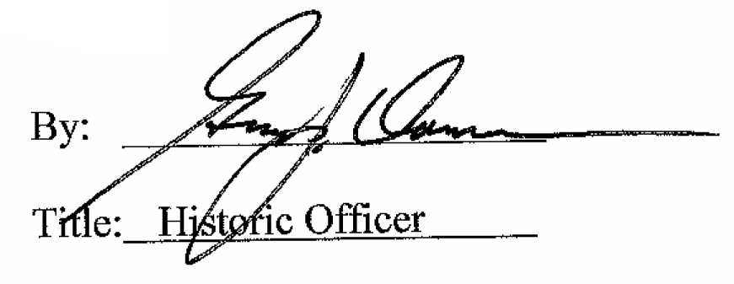

Date of Meeting: February 1, 2017

